# GLA UNIVERSITY, MATHURA

## UTTAR PRADESH

**CLOUD BASED BUS PASS SYSTEM**

SAKSHAM JOHRI, AAYUSHI RAI, PRANJUL SINGHAL

GUIDED BY: Mr. VIVEK SHARMA

Student, Department Of Computer Engineering and application

[saksham.johri_ccv17@gla.ac.in](mailto:saksham.johri_ccv17@gla.ac.in), [ayushi.rai_ccv17@gla.ac.in](mailto:ayushi.rai_ccv17@gla.ac.in),

pranjul.singhal_ccv17@gla.ac.in

**Abstract:**The project entitled “Bus Pass System” is developed using HTML and CSS as Front end and PHP as Back end. Bus pass registration is useful for passengers who are facing problems with the current manual work of bus pass registration and renewal. His/her renewal or registration can be done through online transaction. In the manual system the user has to go on particular date and time, if they fail then the renewal cannot be done. This online bus pass system application will help candidates save their time and renewal bus pass without standing in a line for hours. Initially user needs to register with the application by submitting their details through online. The administrator will verify the candidate username and password and renewal are performed. The renewal process is carried by paying the money using the online transaction.

**Keywords:**Bas Pass Generation, Renewal, Online transaction.

# Introduction

We are creating this project to provide a safe reliable time saving and affordable services for people although the cost for providing the service has been substantial. Because of the drawback that are present in the existing system and the user had to do all the work manually we got this idea that would help people in better way and this system will help people to do their work bit faster. In this system we have to do all the process online such as filling the form and other details such as candidate name, date of birth, Email-id, validity period, amount paid etc. After filling the form all the details will be verified by the admin after the verification if the pass is generated user can take the print. Furthermore user need to do all the transaction online. Hence, there is a need of reformation of the system with more advantage and flexibility. The bus scheduling and booking system eliminate most of the limitation of the existing.

# Related Work

Online bus pass generation is already implemented in many parts of the world. Online bus pass generation system is helpful as it reduces the paper work time consumption and makes the process of getting bus pass simple and fast.

We have compared the existing system of the different state as our system will consist several advantages over the present system. In our system we can do all the things online such as Registration, filling the form, other details etc. after the verification if the admin is satisfied with your document proof and other details they will approve bus pass. If the user will get mail he/she can take the print of bus pass through its email-id. User can even renew the pass using credit card or other transfer method.

# Proposed System

The proposed system is intended to overcome the major drawbacks of the existing manual system.

### Cloud Based Bus Pass System

This system is easy to design and implement. It requires very low system resources .our system consist of various advantages over the present manual system. Our system consists of websites forms as well as admin modules. Website forms will be for the particular user as well as software module will be for the admin.

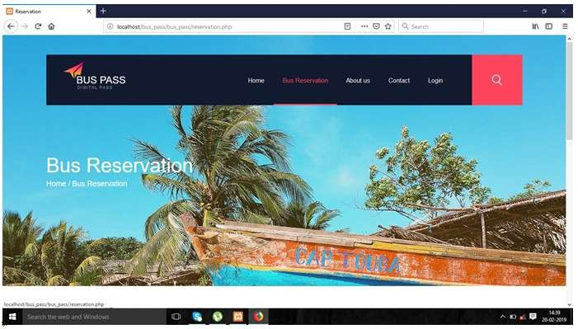

Our system consist of following features Website Module Website Forms

* General Registration Form
* General Login Form
* Personal Details Form
* Bank Details

#### Admin Modules

* Personal Details Verification
* Confirm Booking
* Bus in time and out time Details

#### Website Form

1. **General Registration Form**

In this module passengers must register for getting their login id and filling personal details

### Cloud Based Bus Pass System

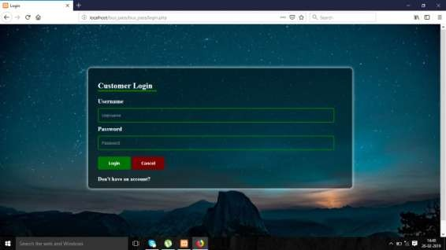

#### Personal Details Form

In this module student can fill their personal details like Name, Address, Phone No, School or College Name, From City, To City etc.

#### Login Form

In this module Employee must input their username and password for accessing the next section.

***IOSR Journal of Engineering (IOSRJEN)*** [***www.iosrjen.org***](http://www.iosrjen.org/)

*ISSN (e): 2250-3021, ISSN (p): 2278-8719*

*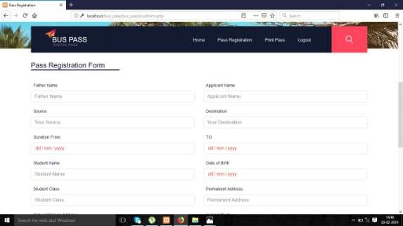PP 61-65*

*In this module student can fill their personal details like Name, Address, Phone No, Adhar Card No, Company Name, company Address, From City, To City etc.*

#### Bank Details Form

*In this module student and employee must enter their bank account details because all fees deducted from onlinetransaction.*

#### Bus Reservation Form

*In this module people can book the bus for any purpose like weddings, Tour, long drive party etc.*

***Admin Modules***

1. ***Student Personal Details Verification***

*In this module depot manager can verify the details and document submitted by student and verify it this process will take the 5 to 10 minutes.*

#### Employee Personal Details Verification

*In this module depot manager can verify the details and document submitted by Employee and verify it this process will take the 5 to 10 minutes.*

#### Reservation Details

*In this module depot manager can see the booking details of bus booked by the peoples and manager can provide the bus facility for their purpose*

#### Confirm Booking

*In this module depot manager can book the bus and provide bus no for the identification of the bus.*

#### Conductor Details

*In this module manager can manipulate the conductor details and take the attendance of the conductor if it is present or not on their duty.*

#### Driver Details

*In this module manager can manipulate the driver details and take the attendance of the driver if it is present or not on their duty.*

#### Bus in time and out time Details

*In this module manager can manipulate the bus details and take the in time and out time of the bus*

# Conclusion

Bus pass generation project which is useful for the students who are facing problems with the current manual work of bus pass registration and renewal. It also increases the validity period. This online bus pass registration application will help students save their time and renewal bus passes without standing in a line for hours near counters. Initially students need to register with the application by submitting details of address proof, candidate name, e-mail id, mobile number, date of birth and bank detailsare required and submitted online. They will verify yours detail and if they are satisfied they will approve bus pass. You can even renewal using credit card or other online transfer methods.

### Cloud Based Bus Pass System

# *References*

*[1]. S.Kim,"Security Augmenting Scheme for Bus Information System based on smart Phone International Journal of Security and its Application.*

*[2]. S.Chandurkar Implementation of Real Time Bus Monitoring And Passenger Information System. international Journal of Scientific And Research Publication.*

*[3]. DevelopmentofanEffectiveOnlineBusPassGenerationSystemforTransportationService in Karnataka State*

*[4]. Baid.A, Rae.I, Li.J, Doan.A, and Naughton.J,(2010) “Toward Scalable Keyword Search over Relational Data,” Proc. VLDB Endowment, vol. 3, no. 1, pp. 140-149.*

*[5]. Bhalotia. G, Hulgeri.A, Nakhe.C,, and SudaChakrabarti.S18th rshan.S,(2002) “Keyword Searching and Browsing in Databases Using BANKS,” Proc. Int‟l Conf. Data Eng. (ICDE ‟02), pp. 431-440.*